Olympic Run Record

### Introduction

The objective of this project was analyzing the data of the Olymic run record to cluster countries based on their run records using different clustering methods and to analyze which one would produce the best result.

### K-means clustering

# Set random seed.  
set.seed(1)  
  
# Explore your data with str() and summary()  
str(run_record)

## 'data.frame': 54 obs. of 8 variables:  
## $ X100m : num 10.23 9.93 10.15 10.14 10.27 ...  
## $ X200m : num 20.4 20.1 20.4 20.2 20.3 ...  
## $ X400m : num 46.2 44.4 45.8 45 45.3 ...  
## $ X800m : num 106 104 106 104 107 ...  
## $ X1500m : num 221 212 215 214 222 ...  
## $ X5000m : num 800 776 796 770 878 ...  
## $ X10000m : num 1659 1652 1663 1612 1829 ...  
## $ marathon: num 7774 7651 7933 7632 8782 ...

summary(run_record)

## X100m X200m X400m X800m   
## Min. : 9.78 Min. :19.32 Min. :43.18 Min. :101.4   
## 1st Qu.:10.10 1st Qu.:20.17 1st Qu.:44.91 1st Qu.:103.8   
## Median :10.20 Median :20.43 Median :45.58 Median :105.6   
## Mean :10.22 Mean :20.54 Mean :45.83 Mean :106.1   
## 3rd Qu.:10.32 3rd Qu.:20.84 3rd Qu.:46.32 3rd Qu.:108.0   
## Max. :10.97 Max. :22.46 Max. :51.40 Max. :116.4   
## X1500m X5000m X10000m marathon   
## Min. :206.4 Min. : 759.6 Min. :1588 Min. : 7473   
## 1st Qu.:213.0 1st Qu.: 788.9 1st Qu.:1653 1st Qu.: 7701   
## Median :216.6 Median : 805.2 Median :1675 Median : 7819   
## Mean :219.2 Mean : 817.1 Mean :1712 Mean : 8009   
## 3rd Qu.:224.2 3rd Qu.: 834.5 3rd Qu.:1739 3rd Qu.: 8050   
## Max. :254.4 Max. :1002.0 Max. :2123 Max. :10276

# Cluster run_record using k-means   
run_km = kmeans(run_record , 5, nstart = 20)  
  
# Plot the 100m as function of the marathon. Color using clusters  
plot(run_record$marathon ,run_record$X100m , col = run_km$cluster , xlab = "Marathon" , ylab = "100m")

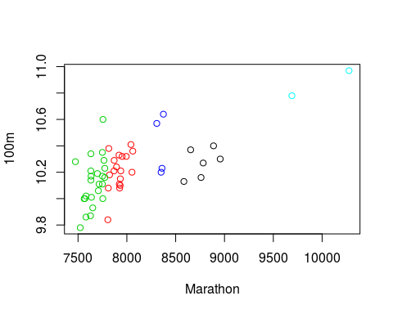

# Calculate Dunn's index  
dunn_km = dunn(clusters = run_km$cluster ,Data = run_record)  
dunn_km

## [1] 0.05651773

As you can see from the plot the the unstandarized clusters are completely dominated by the marathon records; you can even separate every cluster only based on the marathon records. Moreover Dunn's index seems to be quite low.

### K-means clustering on standardized data

In order to get satisfying results, the data needs to be standardized which is done using scale function.

# Set random seed.   
set.seed(1)  
  
# Standardize run_record, transform to a dataframe  
run_record_sc = as.data.frame(scale(run_record))  
  
# Cluster run_record_sc using k-means  
run_km_sc = kmeans(run_record_sc , 5, nstart= 20)  
  
# Plot records on 100m as function of the marathon.   
plot(run_record_sc$marathon ,run_record_sc$X100m , col = run_km_sc$cluster , xlab = "Marathon" , ylab = "100m")

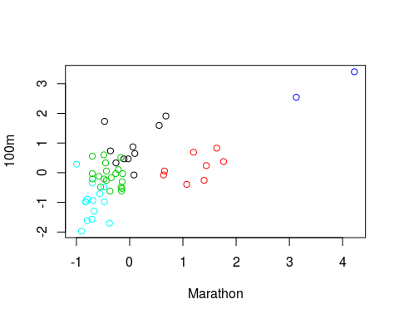

# Compare the resulting clusters in a table  
table(run_km$cluster , run_km_sc$cluster)

##   
## 1 2 3 4 5  
## 1 0 6 0 0 0  
## 2 7 0 10 0 1  
## 3 1 0 10 0 13  
## 4 2 2 0 0 0  
## 5 0 0 0 2 0

# Calculate Dunn's index  
dunn_km_sc = dunn(clusters = run_km_sc$cluster ,Data = run_record_sc)  
dunn_km_sc

## [1] 0.1453556

The plot now shows the influence of the 100m records on the resulting clusters! Dunn's index is clear about it, the standardized clusters are more compact and better separated.

### Hierarchical clustering with single linkage

# Apply dist() to run_record_sc  
run_dist = dist(run_record_sc )  
  
# Apply hclust() to run_dist  
run_single = hclust(run_dist , method = "single")  
  
# Apply cutree() to run_single.  
memb_single = cutree(run_single , k =5)  
  
# Apply plot() on run_single to draw the dendrogram  
plot(run_single )  
  
# Apply rect.hclust() on run_single to draw the boxes  
rect.hclust(run_single ,k= 5 ,border = 2:6)

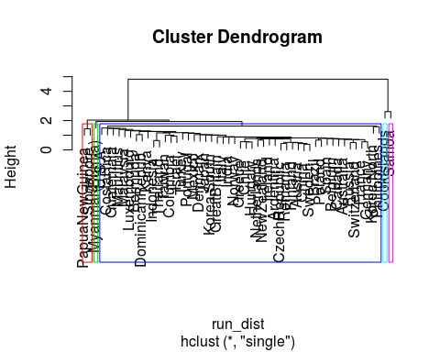

As you can see from the plot that there are two islands Samoa and Cook's Islands, who are not known for their sports performances, have both been placed in their own groups. The single-linkage method appears to be placing each outlier in its own cluster.

### Hierarchical clustering with complete linkage

# Apply hclust() to run_dist  
run_complete = hclust(run_dist , method = "complete")  
  
# Apply cutree() to run_complete  
memb_complete = cutree(run_complete , k =5)  
  
# Apply plot() on run_complete to draw the dendrogram  
plot(run_complete)  
  
# Apply rect.hclust() on run_complete to draw the boxes  
rect.hclust(run_complete ,k =5, border = 2:6)

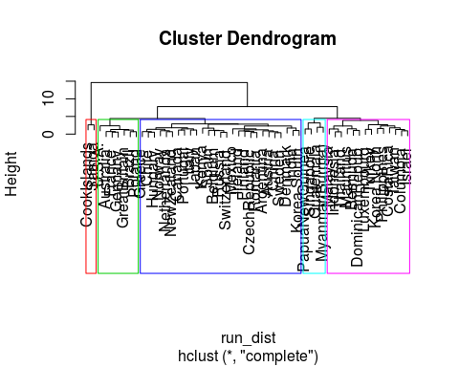

# table() the clusters memb_single and memb_complete.  
table(memb_single , memb_complete )

## memb_complete  
## memb_single 1 2 3 4 5  
## 1 27 7 14 0 1  
## 2 0 0 0 1 0  
## 3 0 0 0 0 1  
## 4 0 0 0 0 2  
## 5 0 0 0 1 0

Compare the two plots. The five clusters differ significantly from the single-linkage clusters. That one big cluster is now split up into 4 medium sized clusters.

### Comparing Dunn's Index

Compare the Dunn's index of the three clustering methods to see which will give the best results.

# Set random seed.   
set.seed(100)  
  
# Dunn's index for k-means  
dunn_km = dunn(cluster = run_km_sc$cluster , Data = run_record_sc)  
  
# Dunn's index for single-linkage  
dunn_single = dunn(cluster = memb_single , Data = run_record_sc)  
  
# Dunn's index for complete-linkage  
dunn_complete = dunn(cluster = memb_complete, Data = run_record_sc)  
  
# Compare k-means with single-linkage  
table(run_km_sc$cluster,memb_single)

## memb_single  
## 1 2 3 4 5  
## 1 9 0 1 0 0  
## 2 6 0 0 2 0  
## 3 20 0 0 0 0  
## 4 0 1 0 0 1  
## 5 14 0 0 0 0

# Compare k-means with complete-linkage  
table(run_km_sc$cluster ,memb_complete )

## memb_complete  
## 1 2 3 4 5  
## 1 0 0 8 0 2  
## 2 0 0 6 0 2  
## 3 20 0 0 0 0  
## 4 0 0 0 2 0  
## 5 7 7 0 0 0

In conclusion the single-linkage method returned the highest ratio of minimal intercluster-distance to maximal cluster diameter thereby giving the most accurate result out of the three methods.